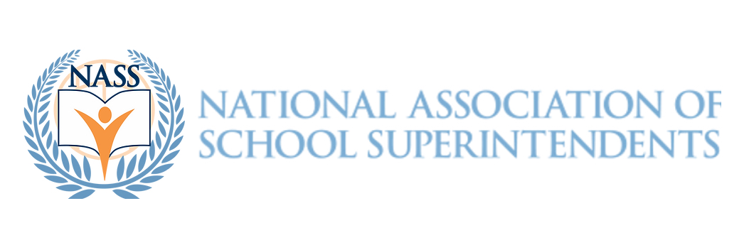
FOR IMMEDIATE RELEASE

Lisa Harrod Emerges as a Finalist for NASS 2023 Superintendent of the Year

Reno, NV - December 7, 2023 - The National Association of School Superintendents (NASS) is proud to announce Lisa Harrod as a finalist for its prestigious 2023 Superintendent of the Year award. With her commitment to continuous improvement and innovation in education, Harrod has made significant strides in her district, particularly in curriculum alignment and leadership development.

This school year, Harrod has led several notable initiatives, including restarting the curriculum review process, focusing on English and Math alignment, and introducing a robust Junior/Senior Leadership Class program. She has also been instrumental in establishing an 8th/9th grade academy focused on public speaking, demonstrating her dedication to preparing students for real-world challenges from an early age.

Harrod's leadership philosophy centers on creating a positive culture and climate where teachers are motivated and students are central to every decision. Her annual "Harrod 90-10 talk" emphasizes resilience and forward-thinking, urging staff to focus on the bigger picture and stay aligned with the district's goals.

When faced with challenges, such as the unexpected results of the Opportunity Hour initiative, Harrod has shown remarkable ability to adapt and rebound, reinforcing her credentials as a leader who can navigate through uncertainty with grace and effectiveness.

If selected as the NASS 2023 Superintendent of the Year, Harrod plans to share her belief in collaboration, respect, and the power of storytelling in education. She emphasizes the importance of providing resources and support for superintendents, especially in areas like politics, budgeting, and public communication.

Harrod is committed to mentoring and supporting her peers, drawing on her extensive background in professional development. She believes in adapting to the times without fear, embracing technology, and building relationships based on trust to create a positive impact for students and staff.

Describing herself as passionate, dedicated, and forward-thinking, Harrod stands out for her commitment to enhancing community training and parental involvement in education. She is driven by the desire to provide the best possible experiences and opportunities for her students and staff.

Harrod is eager to serve on the advisory committee and contribute further to the NASS community. She assures, "I won’t let you down. It’s a prestigious honor. I see all of you as committed to getting information out with strong messages."

For more information, please contact Theresa Daem, Founder - National Association of School Superintendents, tdaem@nass.us

###

