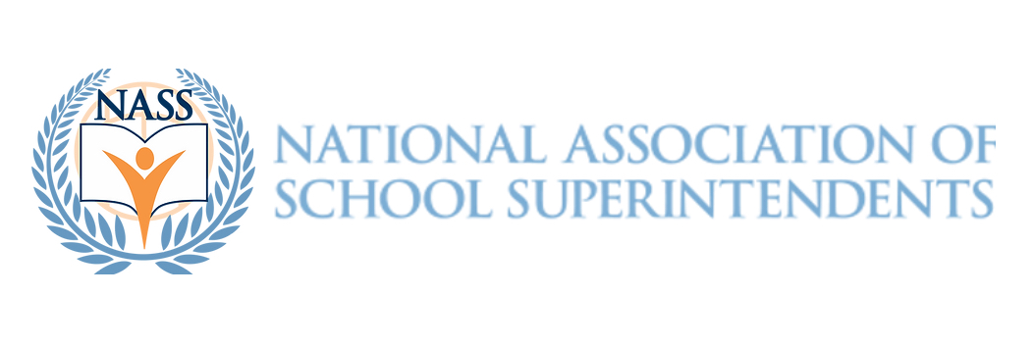

FOR IMMEDIATE RELEASE

Kirk Koennecke Named as Finalist for the 2023 Superintendent of the Year by the National Association of School Superintendents

Reno, Nevada - December 7, 2023 - Kirk Koennecke has been announced as a finalist for the prestigious National Association of School Superintendents (NASS) 2023 Superintendent of the Year award. In his current role leading a suburban district on the northeast side of Cincinnati, Koennecke has demonstrated exceptional leadership and innovation in education.

Koennecke's tenure is marked by significant achievements, including the successful passage of a historic Bond Levy, the first in 20 years, to bolster the district's facilities. Under his guidance, the district saw the opening of a new Fine Arts center, a testament to the community's commitment to supporting comprehensive education. This year, students were featured on "Good Morning America" for a Frozen-themed contest with Disney, celebrating the 10-year anniversary of this collaboration. Additionally, the district's Performing Arts students performed a sold-out K12 production, showcasing the talent fostered under Koennecke's and his team’s leadership. Koennecke is quick to point out his entire team and community’s collective commitment to public education and student success.

His strategic plan, the "IH Promise," developed during the pandemic, became a national model for strategic planning in education. This plan focuses on the 'whole child' approach, placing students at the center of all educational endeavors. Koennecke's commitment to high expectations and regular progress monitoring has been crucial in this success.

Despite challenges like the pandemic, Koennecke has skillfully navigated through uncertain times, maintaining a strong focus on unity and community support. His leadership philosophy centers around educational equity and the critical role of educators in shaping future generations. Koennecke is a proponent of investing in public education and addressing national gaps urgently.

If selected as the NASS 2023 Superintendent of the Year, Koennecke aims to use this platform to champion the importance of educational equity and the vital role of talented educators in the success of public schools. He is also committed to serving on the advisory committee, leveraging his vast network to support and develop future educational leaders.

Koennecke describes himself as humble, a servant, and a teammate, embodying the qualities essential for effective educational leadership. His dedication to modernizing education, including embracing AI and enhancing critical thinking skills, positions him as a forward-thinking leader in the field.

For more information, please contact Theresa Daem, Founder, National Association of School Superintendents at tdaem@nass.us

###

